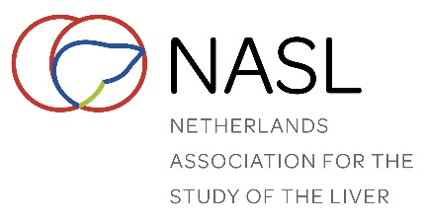
On-site registration
Dutch Liver Retreat 2023, February 2-3, Zwolle

Title
Initials
First name
Surname
NVH member | yes / no*
Home address
Zip code / City
Function
Institute
Department
Address
Zip code / City
Telephone number
E-mail address

Overnight stay
Share room with***

*** Single rooms only available upon request (Indicate reason). Please send the registration form together with your roommate.

Special diet wishes

Registration fee****
 | NVH member - Registration incl. single room | € 325,00
 | NVH member - Registration incl. double room | € 250,00
 | NVH member - Registration without overnight stay | € 275,00
 | Non-member - Registration incl. single room | € 400,00
 | Non-member - Registration incl. double room | € 325,00
 | Non-member - Registration without overnight stay | € 350,00
**** Indicate as appropriate

Payment with direct debit (automatische incasso) only.
By signing below, you authorize the “Nederlandse Vereniging voor Hepatologie” to withdraw the registration fee from your account

IBAN

Name and initials of the account holder: Signature:

________________________________ ________________________

More information about registration:
Secretary of the “Nederlandse Vereniging voor Hepatologie” | Postbus 657, 2003 RR Haarlem
Telephone: 023 – 551 3016 | e-mail: secretariaat@nvh.nl

