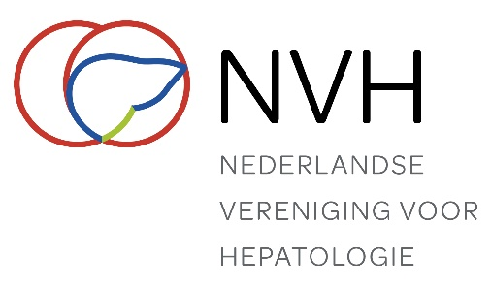
Application form thesis sponsorship
For conditions see page 2

Name of applicant: |  |  | Gender: M / F
Work address
Institute:
Department:
Street:
Post code and town/city:
Telephone:
E-mail:
Home address
Street:
Post code and town/city:
Position (research-assistant or other):
Title thesis:
Promotion date:
Motivation application:
(explain the hepatological nature of the thesis, where results presented at international conferences, have sections of the thesis been published?
Abstract presented during the NASL congress at Veldhoven or the DLR: | Date: Title:
IBAN:
In the name of: |  | At:

Date:

________________________
Signature

Send application to: ledenadministratie@nvh.nl

Send dissertation book to:
NASL secretarial office
P.O. Box 657
2003 RR Haarlem
Conditions thesis sponsorship

Thesis sponsorship
Subject to certain conditions, the Netherlands Association for the Study of the Liver will pay an amount of €500 towards the cost of printing dissertations. This arrangement is intended to support trainee research assistants (or researchers on a similar salary). Details of the sponsorship conditions are set out below. There will be strict compliance with these requirements.
On the date of their PhD defence, the beneficiary must have been a member of the Netherlands Association for the Study of the Liver for a minimum of two years. The date of registration is taken as the date of commencement of membership.
The beneficiary must hold the position of trainee research assistant, or occupy a position with a comparable salary.
The thesis must involve either a basic scientific investigation or a clinical investigation of a hepatological topic*. This will be jointly assessed by the secretary and the treasurer.
The research (or parts thereof) has been presented to the Netherlands Association for the Study of the Liver during sessions of its meetings at Veldhoven or during the Dutch Liver Retreat.
The application must be submitted two months before the date of the PhD defence and must be accompanied by a brief abstract (approx. 300 words) in the style of a press release and phrased in terms that are comprehensible to the ‘uninitiated’. Following the award of the PhD, the summary will be published on the restricted section of the NASL website and in ‘LEVER’ (LIVER).
The NASL’s sponsorship must be acknowledged in the thesis.

*The applicant can demonstrate the hepatological nature of the thesis if:
- Sections of the thesis have been published in hepatological journals, or in hepatological sections of gastroenterological journals;
- The results described in the thesis have been presented at hepatological conferences (AASLD, EASL) or at hepatological sessions of gastroenterological congresses (AGA/DDW, UEGW).

